**Programming Assignment**

**Encryption Program – String Functions**

In this program you are going to write several string functions that can be used for encrypting and decrypting messages. A sample run of the program is shown below. The only thing the user enters is the message. You will write the functions to encrypt and decrypt the message entered by the user.

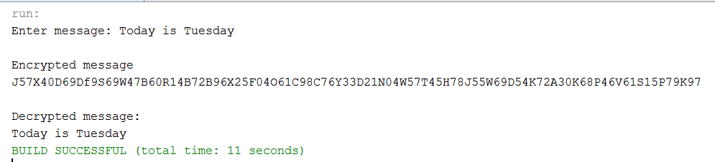

Please note that the decrypted message you return must result from the *DecryptMessage*  function you write. You cannot just echo the message plaintext string.

**The Encryption Algorithm**

You should build your encrypted text using the following pseudocoded algorithm.

*For each character in the message*

*Get the current character*

*Convert the character into a two-character hexadecimal string*

*Create a new 4-character string that consists of the concatenation of*

*a random character + the first hex digit + a random character + the second hex digit*

*Concatenate this new character to the encrypted text you are going to return*

For example, if you send the message “h”, the hexadecimal code for “h” is 68, using ASCII encoding. The first hex digit is 6 and the second hex digit is 8. Your algorithm should return something like “U**6?8**” depending on the random characters generated by your method. The result is a four-character string. Note the random characters are interspersed between the 68.

To convert a character to a hexadecimal ASCII string:

*hexCharacter = Integer.toHexString(character);*

One easy way to get a random character is to set up a long string of characters. For example, in my implementation of the program, I used (copy this if you want to use it):

*final String randomCharacters = "a;BC?<de01%$@fG*!h23IJ45Kl67m89nOPQrsTUvwXYz";*

Set up a random number generator to return an integer between 0 and the length of your random character string. Get a random integer and use the *charAt* function to get the character at the random index. For example

*char randomChar = randomCharacters.charAt(generator.nextInt(numRandomChars));*

where *numRandomChars* is the length of your random string.

**The Decryption Algorithm**

Your decryption algorithm needs to restore the original message by removing the random characters to recover the original hexadecimal code for the character. Remember that each character has been turned into a 4-character string. So, you will have to extract the 4 encoded characters that make up each character in the original message as a unit. Also remember that the character you extracted is coded as a hexadecimal string. To recover the original character from the hexadecimal string you can use the following line of code

*c = (char) Integer.parseInt(character,16);*

Here’s a pseudocoded version of the decryption algorithm.

*For the length of the encrypted string*

*Extract 4 characters*

*Reconstruct the original hex string by removing the 2 random characters*

*Recover the character encoded by the hex string*

*Concatenate the character to the decoded string you are going to return*

*Return the decoded string*

Before you start this program be sure you have studied string functions and for-loops in the text and the string function examples we did for class. You also have to pay attention to the difference between the data types char (character) and String. They are different and the functions that work on them are different.

Since you are practicing writing string and character functions in this assignment, we are going to construct the program in a particular way. The main function of the program is given below. Your job is to write the 4 functions discussed below.

The main procedure and stubs for the required function will be provided below. You should not make any changes to the main procedure.

Copy the code on the next 2 pages below and use it as the basis for your project. Again, **Do not modify the main procedure. Write only the four string functions.**

public static void main(String[] args)

{

Scanner sc = new Scanner(System.in);

String plainText, encryptedText, decryptedText;

System.out.print("Enter message: ");

plainText = sc.nextLine();

System.out.println();

System.out.println("Encrypted message");

encryptedText = EncryptMessage(plainText);

System.out.println(encryptedText);

System.out.println();

System.out.println("Decrypted message:");

decryptedText = DecryptMessage(encryptedText);

System.out.println(decryptedText);

}

You need to implement the four string and character functions *EncryptCharacter*, *DecryptCharacter*, *EncryptMessage*, and *DecryptMessage*. See the examples below to get you started.

// This function takes a character and returns it as an encrypted 4-character string

public static String EncryptCharacter(char character)

{

// You need to implement this function

}

// This function takes an encrypted character string and returns a decrypted character

public static char DecryptCharacter(String encryptedCharacter)

{

// You need to implement this function

}

// This function takes a plaintext message and returns the message as an encrypted string.

public static String EncryptMessage(String plainText)

{

// You need to implement this function

}

// This function takes an encrypted message and returns it as a decrypted message.

public static String DecryptMessage(String encryptedText)

{

// You need to implement this function

}